- Challenge Name and Category: Printer Shares (General Skills)
- Difficulty/Points: Easy
- Description: Oops! Someone accidentally sent an important file to a network printer—can you retrieve it from the print server? The printer is on 50380, you can try $ nc -vz mysterious-sea.picoctf.net 50380
- Flag: picoCTF{5mb_pr1nter_5h4re5_2f61915b}
- Solution/Walkthrough: To begin we have to see if the server port is open by using net cat, nc -vz mysterious-sea.picoctf.net 50380. The output states that the connection was successful and that the printer was connected.
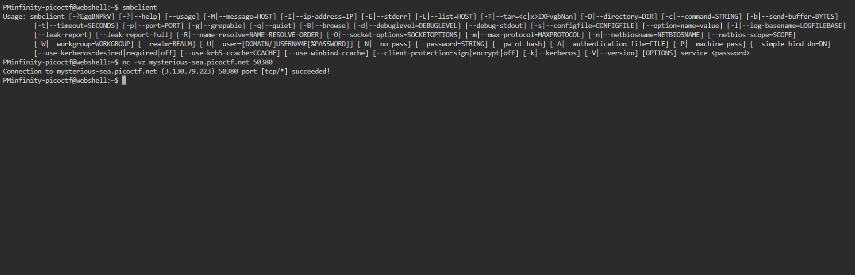
The output hints that the printer in question used the SMB protocol, so we will use SMB client to enumerate the shares, smbclient -L //mysterious-sea.picoctf.net -p 50380 -N
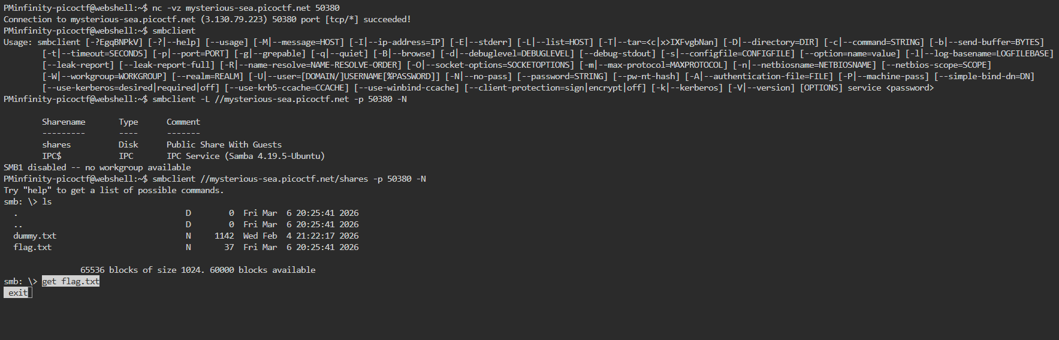
This showed the public share names which we connected to using smbclient //mysterious-sea.picoctf.net/shares -p 50380 -N. This leads to the SMB prompt, smb: \>. We’ll list the files inside the share using ls, this gives us the files dummy.txt, and flag.txt. We’ll retrieve the flag using get flag.txt and exit. Lastly to get the flag we will “cat exit”. Typically, this would be “cat flag.txt”. The cat function will output our flag.
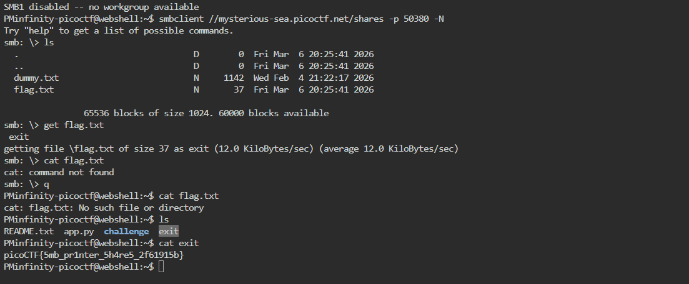
- Tools Used: Web Shell, Net Cat
- Hypothesis Formulation: There should be a way to access the open port and view the files that were sent to the printer.
- What Worked vs. What Didn't: For some reason when I tried to retrieve the flag using get flag.txt it saved as exit while I was trying to return to local. I ended up having to cat exit to get the flag.

